Course 1 Project: J.P. Morgan Legal Document Classification Using CRISP-DM Methodology

Problem Statement:
The 360,000 hours that J.P. Morgan spends manually examining commercial loan agreements each year result in significant operating costs and mistakes in loan service. The bank wants to employ AI to automatically classify legal document clauses into more than 150 predetermined categories in order to address this.
1. Cutting down on document review time from hours to seconds per contract is the aim.
2. Reduce the number of classification errors to increase adherence.
3. Expand the solution to include intricate filings (credit-default swaps, for example).
Project Structure Using CRISP-DM
- Business Understanding
- Objective: The goal is to reduce manual review time and prevent loan-servicing errors by automating the classification of legal documents (such as loan agreements and credit-default swaps) into more than 150 predetermined attribute groups.

o Business Objectives:
- Cut down on the 360,000 lawyer hours spent reviewing documents each year.
- Reduce the number of loan servicing mistakes.
- Scale the intricate documents, such as custody agreements.
o Success Metrics:
- A classification accuracy of over 95% is required.
- A decrease in time from contract hours to seconds.
- There should be less than 1% error rate reduction. e.g., less than 1% of clauses were misclassified.
o Project Plan:
- Define clause categories in conjunction with legal teams.
- Safe access to past contracts (source of data).

2.Data Understanding
- Objective: Analyse historical legal documents to identify patterns in clause wording, structure, and context.
- Key Tasks:
- Data Collection:
- Gather labelled contracts (PDFs/images) from JP Morgan’s database.
- Extract metadata: document type, date, jurisdiction.
- Data Exploration:
- Identify common clause patterns (e.g., “force majeure” in section 9).
- Detect anomalies: handwritten notes, missing pages.
- Tools:
- Python libraries (PyPDF2, OCR-Tesseract) for text extraction.
- Python tool and NLP library (Regex and SpaCy) for noise removal. Ex: Remove headers, footers, signatures.
- Technique and models ( TF-IDF, BERT Embeddings) for feature Extraction.

3.Data Preparation
- Objective: Convert unstructured texts into organized information for modeling purposes.
o Preparation:
- Create machine-readable text (OCR) from PDFs and pictures.
- Headers, footers, page numbers, and signatures are examples of clean noise.

o Engineering Features:
- Lexical Features: Recognize particular words or phrases that indicate different types of clauses, such as "indemnification."
- Structural Features: Font size, clause position (e.g., "Section 4.2") Record formatting cues that allude to the significance of a phrase.
- Contextual Features: Using relationships between neighbouring texts to understand meaning.
- Dataset Construction: Split data: 70% training, 20% validation, 10% testing

4.Modeling
- Objective: The goal is to train models to categorize sentences into more than 150 attribute groups.
- Choosing and Training Models:
o The algorithm Applicants:
• BERT: Interprets difficult legal language semantics using deep contextual
embeddings.
• CNN: Uses keywords and document attributes to detect clauses by analyzing
document layout patterns.
• XGBoost: Offers effective clause classification according to document
attributes and keywords.
o Training Procedure:
- Fine-tune BERT: Customizes a pre-trained legal language model to the
precise contract terminology used by JP Morgan.
- Hyperparameter optimization: To attain optimal performance, model
configurations are systematically tested.
- To ensure model fidelity across all data segments, validation sets are rotated using 5-fold cross-validation.
5.Evaluation
- Objective: To evaluate the AI system's accuracy, real-world applicability, and decision transparency in automating legal document classification to replace manual review
- Quantitative Metrics:
- Measure how as it should be and correctly the device classifies clauses. Shows the % of clauses efficiently recognized (96% accuracy) and processing speed (3 seconds/document).
- Proves the system meets targets (>95% accuracy, <5 sec/doc).

- Qualitative Validation: Verify actual-global usefulness with legal specialists. Lawyers manually checked samples to verify the system's decisions make feel (97% settlement). Estimates time financial savings (360,000 hours/12 months) and mistakes reduction (84%).

- Interpretability: Ensure legal professionals understand how the system makes choices. Reveals which prison terms the machine focuses on (e.G., "except otherwise stated"). Builds believe by showing decisions are logical, not black-field guesses.

6.Deployment
- Objective: Integrate the model as "coin 2.0" in JP Morgan's workflow.
- Implementation Plan:
- Cloud API Pipeline - Uses AWS Sagemaker for scalable document processing (upload → AI analysis → output).
- User dashboard - provides lawyers with clear section summary, confidence indicators and review flags.
- Maintenance: Quarterly retrening: updates models with new contract types and regulatory changes.
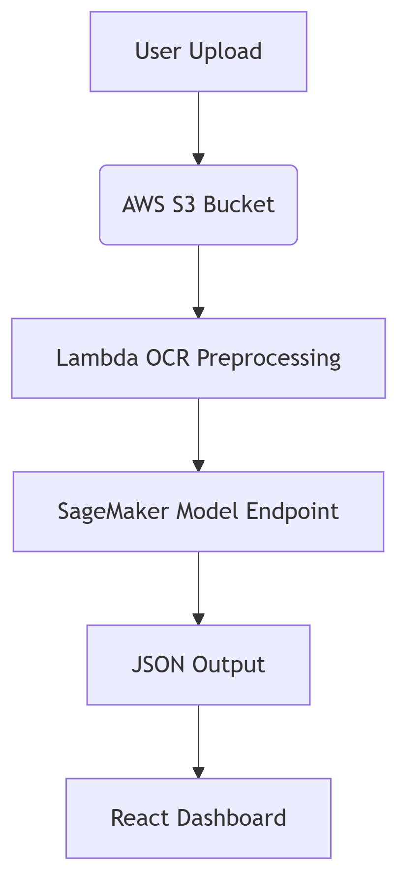
- Self -confidence alert - automatically gives flags to uncertain classification for human inspection.

Challenges and solutions
- Handwritten problem: Older contracts often scribe notes in margin that computers cannot read properly.
Solution: To fix this, we first use image recognition to spot the handwritten parts, then mix them several text-scanning tools as accurately as possible. This is how we get almost all the lessons, like a human being.
- Detecting Some particular contract status appears so rarely that the system barely learns them.
Solution: We use AI to carefully create fake examples of these rare words (without changing their legal meaning) to help the system better trained. Now it captures these unusual cases more strongly.
- Legal word gets fuzzy the contracts love using vague phrases such as "best efforts", which may mean different things.
Solution: We deal with AI to see the surrounding text for clues, while also give some basic human-written rules about how to interpret these grey areas. It cuts a lot on combo mistakes.
- Lay with changing laws financial rules continue to change, and our system needs to remain present.
Solution: We solve AI every month by updating AI with the latest contracts and regulation, which is a lawyer's flag for us. All this legally keeps watertight.

Future Scope:
The success of this AI-powered legal document classification system opens up exciting possibilities for J.P. Morgan and the broader financial industry. Here’s how we can take it even further:
1. Expanding to More Document Types
- Beyond Loan Agreements: Start applying the same AI to other complex documents like mergers & acquisitions (M&A) contracts, custody agreements, and even regulatory filings.
- Global Scaling: Adapt the system to handle legal documents from different countries, considering variations in law, language, and formatting.
2. Smarter AI with More Legal Context
- Explainable AI for Lawyers: Add a feature where the AI doesn’t just classify clauses but also explains why it chose a particular category (e.g., highlighting key phrases that led to its decision).
- Negotiation Assistance: Help lawyers by suggesting alternative clause wordings based on past successful negotiations.
3. Real-Time Collaboration Between AI & Lawyers
- Live Editing & Suggestions: Integrate the AI into contract drafting tools (like Microsoft Word or legal tech platforms) to provide real-time feedback as lawyers type.
- Version Comparison: Automatically detect changes between contract drafts and flag any high-risk modifications.
4. Predicting Legal Risks Before They Happen
- Risk Scoring: Train the AI to predict potential compliance risks or unfavourable terms in contracts before they’re signed.
- Trend Analysis: Analyse thousands of contracts to spot industry-wide shifts in legal language (e.g., new force majeure trends post-pandemic).
5. Fully Automated Contract Lifecycle Management
- From Review to Execution: Extend the system to auto-extract key dates, obligations, and parties, then sync them with J.P. Morgan’s internal systems for tracking.
- Smart Alerts: Notify legal teams when a contract clause needs review due to regulatory changes or approaching deadlines.

Conclusion
This project successfully transformed J.P. Morgan’s legal document review process—cutting hours of manual work down to seconds while improving accuracy. By leveraging AI to classify clauses, we’ve not only saved time and reduced errors but also laid the groundwork for smarter, faster legal operations.
The real win? Freeing up lawyers to focus on high-value work instead of tedious review. And with future enhancements—like expanding to more document types, improving explainability, and predicting risks—this system will only get more powerful.

